Smart Water Fountain

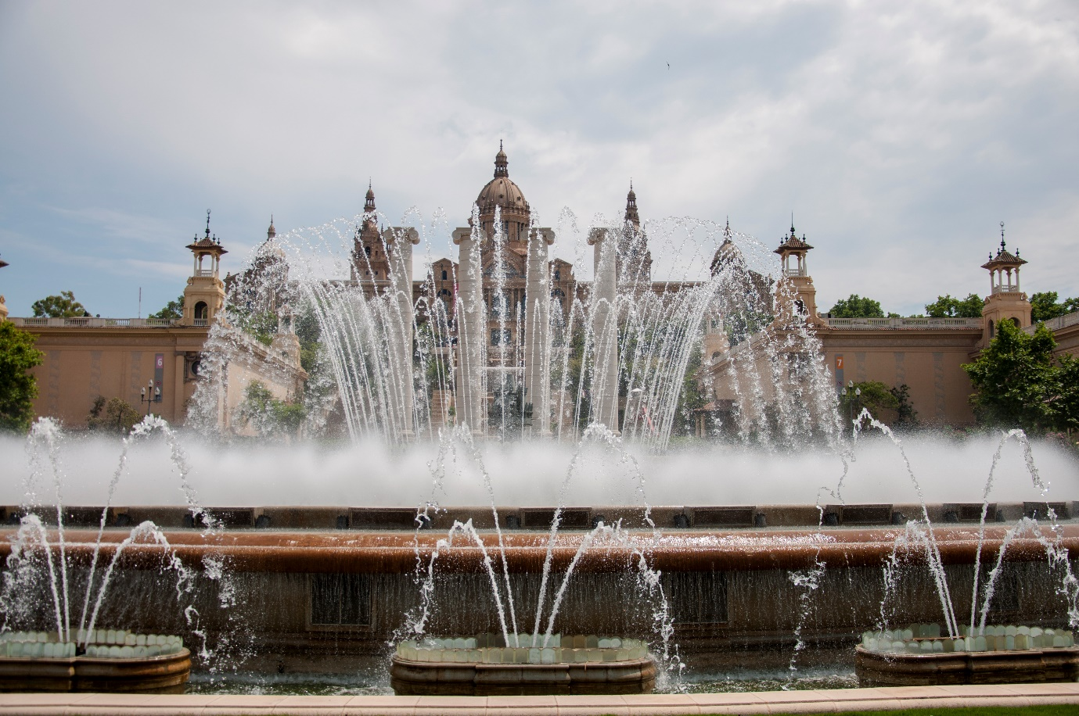

**1.Aesthetic Design:**

* Determining the overall style and theme of the fountain, which can range from traditional to modern, minimalist to ornate.
* Selecting materials that complement the surrounding environment, such as stone, glass, metal, or acrylic.
* Incorporate decorative elements like sculptures, figurines, or unique basin designs to enhance the visual appeal.

**2.Water Flow and Effects:**

* Determining the type of water flow and effects you want, such as cascading waterfalls, laminar jets, or gentle bubbling.
* Use multiple levels, tiers, or basins to create dynamic water patterns and maximize visual interest.

**3.Smart Technology Integration**:

* Microcontrollers or IoT devices to control the fountain's functions.
* Smartphone app or touchscreen interface for user control.
* Remote monitoring and control options for maintenance and adjustments.

**4.Sound Design:**

* Planning for audio elements if desired, such as soothing background music, nature sounds, or the calming sound of flowing water.

**5.Power and Water Supply:**

* Determining the power source for the fountain's components, which may require electrical outlets or solar panels for sustainability.
* Ensure a reliable water supply and a proper drainage system.

[[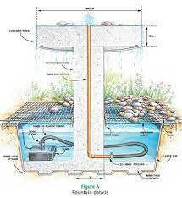](https://www.google.com/imgres?imgurl=https://i.pinimg.com/originals/03/3d/c2/033dc2e0bb55b48e184251b705738ac5.jpg&imgrefurl=https://www.pinterest.com/pin/453808099927930309/&h=489&w=450&tbnid=W9jlJcAfRMY7JM&tbnh=234&tbnw=215&usg=AI4_-kRqfK5F3iQRHZ-20L4hpQXkTLYpxw&vet=1&docid=pRbP3kQ7L0UAtM)](https://www.google.com/imgres?imgurl=https://i.pinimg.com/originals/03/3d/c2/033dc2e0bb55b48e184251b705738ac5.jpg&imgrefurl=https://www.pinterest.com/pin/453808099927930309/&h=489&w=450&tbnid=W9jlJcAfRMY7JM&tbnh=234&tbnw=215&usg=AI4_-kRqfK5F3iQRHZ-20L4hpQXkTLYpxw&vet=1&docid=pRbP3kQ7L0UAtM" \t "_blank)

**6.Size and Location:**

* Deciding on the size and scale of the fountain based on the available space and the desired visual impact.
* Consider the location of the fountain, whether it's indoors or outdoors, and ensure that it fits seamlessly within the environment.

**7.Lighting Design:**

* Integrating RGB LED lighting to illuminate the water and surrounding areas.
* Planning the lighting effects, including color changes, intensity adjustments, and synchronized patterns to create a captivating visual display.

**8.Maintenance and Accessibility:**

* Designing the fountain with easy access to components for maintenance and cleaning.
* Including features like self-cleaning mechanisms or automated water treatment systems to reduce maintenance needs.

**9.Weather Resistance (for outdoor fountains):**

* If the fountain is outdoors, select materials that can withstand various weather conditions, including UV rays, rain, and freezing temperatures.

**10.Interactive Features:**

* Consider interactive elements to engage users, such as touch-sensitive panels, proximity sensors, or responsive water jets that react to movement.

**11.Safety Measures:**

* Ensure the safety of users by designing the fountain with protective barriers or covers for moving parts.
* Incorporate features that prevent water splashing or overspray.

Technology stack

High level requirements

Sensor unit

Physical Design

Display Unit

Mechanical unit

Power supply

Safety Measures

Risk analysis

Control unit

Thank you